**Selected Problems - Chapter 9**

**1.4** The firm will produce 6 units of output. Above 6 units, *MC* rises above *P* = *MR* = $15. *TR* = $90, *TC* = $71, profit = $19. It will operate in the short run because *TR* > *TVC*. It will expand in the long run because *TR* > *TC.*

| *q* | *TFC* | *TVC* | *MC* |
| --- | --- | --- | --- |
| 0 | 25 | 0 | --- |
| 1 | 25 | 7 | 7 |
| 2 | 25 | 12 | 5 |
| 3 | 25 | 18 | 6 |
| 4 | 25 | 25 | 7 |
| 5 | 25 | 34 | 9 |
| 6 | 25 | 46 | 12 |
| 7 | 25 | 62 | 16 |
| 8 | 25 | 88 | 26 |

**3.4** (a)

|  |  |  |  |  |  |  |
| --- | --- | --- | --- | --- | --- | --- |
| Output | *TFC* | *TVC* | *TC* | *AVC* | *ATC* | *MC* |
| 0 | $150 | $  0 | $150 | – | – | – |
| 1 | 150 | 60 | 210 | $60.00 | $210.00 | $60 |
| 2 | 150 | 100 | 250 | 50.00 | 125.00 | 40 |
| 3 | 150 | 180 | 330 | 60.00 | 110.00 | 80 |
| 4 | 150 | 280 | 430 | 70.00 | 107.50 | 100 |
| 5 | 150 | 400 | 550 | 80.00 | 110.00 | 120 |
| 6 | 150 | 560 | 710 | 93.33 | 118.33 | 160 |
| 7 | 150 | 760 | 910 | 108.57 | 130.00 | 200 |
| 8 | 150 | 1,000 | 1,150 | 125.00 | 143.75 | 240 |
| 9 | 150 | 1,300 | 1,450 | 144.44 | 161.11 | 300 |
| 10 | 150 | 1,850 | 2,000 | 185.00 | 200.00 | 550 |

(b)

|  |  |  |
| --- | --- | --- |
| Price | Quantity Supplied | Profit |
| $ 40 | 0 (Shut Down) | −$150 |
| 70 | 2 | −110 |
| 110 | 4 | 10 |
| 140 | 5 | 150 |
| 180 | 6 | 370 |
| 220 | 7 | 630 |
| 260 | 8 | 930 |
| 400 | 9 | 2,150 |

(c)

| Price | Market Quantity Supplied | Market Quantity Demanded |
| --- | --- | --- |
| $ 40 | 0 | 1,700 |
| 70 | 200 | 1,500 |
| 110 | 400 | 1,300 |
| 140 | 500 | 1,100 |
| 180 | 600 | 900 |
| 220 | 700 | 700 |
| 260 | 800 | 500 |
| 400 | 900 | 300 |

(d) Fill in the blanks: From the market supply and demand schedules given, the equilibrium market price for this good is $220 and the equilibrium market quantity is 700. Each firm will produce a quantity of 7 and earn a profit equal to $630.

(e) The equilibrium in this market is not a long-run equilibrium. Because firms are making profits, entry will occur. Entry will increase quantity supplied, and this will decrease equilibrium price until each firm is making zero profit.

**3.6** (a)The firm is making a profit of ($25 − $15) x 600 = $6,000, which is represented by the shaded area.

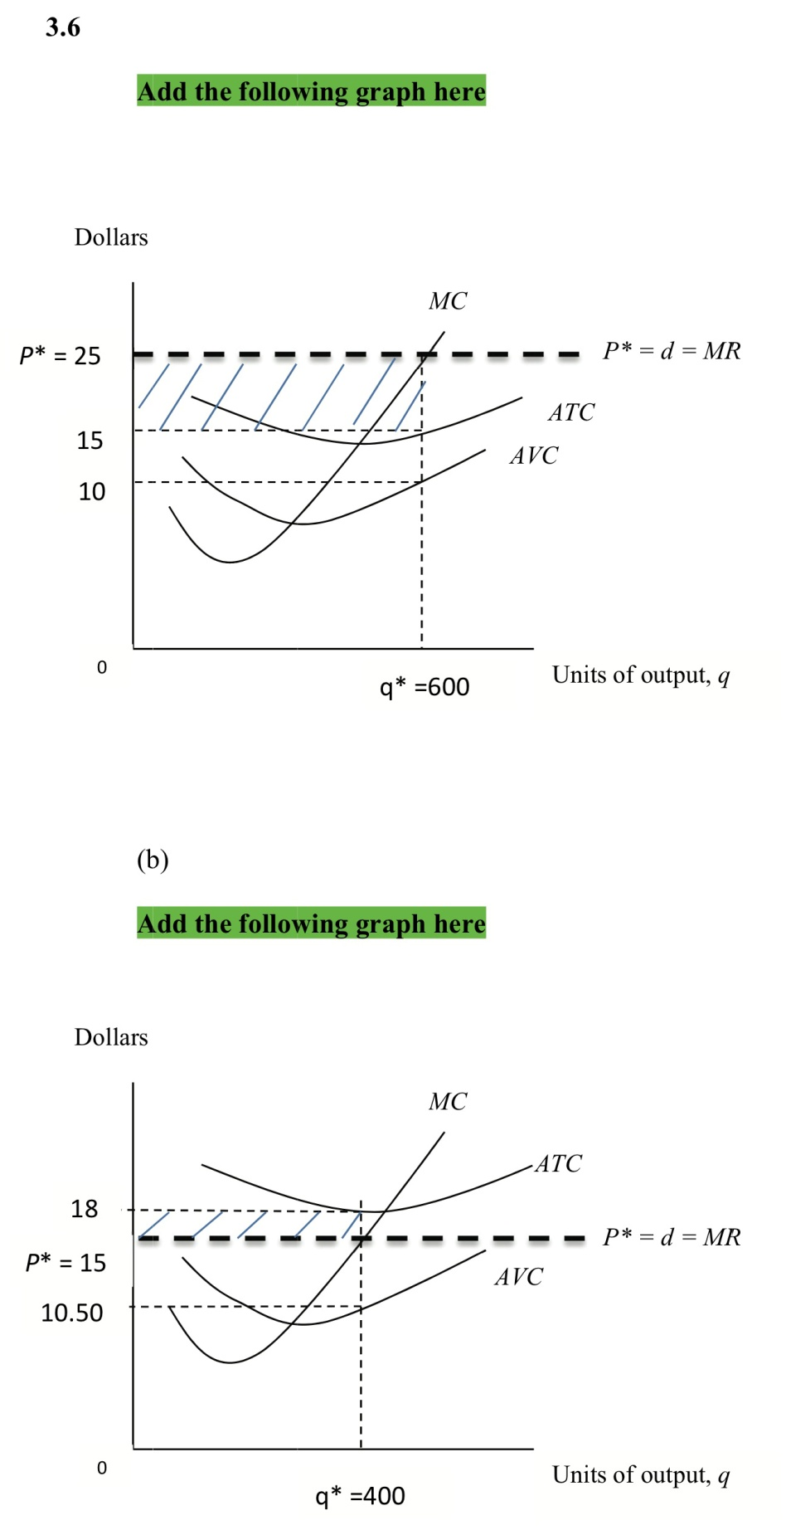

(b)The firm is making a profit of ($15 − $18) x 400 = −$1,200 (a loss of $1,200), which is represented by the shaded area.



(c) The firm is making a profit of ($11 − $21) x 300 = −$3,000 (a loss of $3,000) which is represented by the hatched area. This loss represents the total fixed cost of the firm and the firm shutting down, since price is less than *AVC*.

